**CRIME MANAGEMENT**

1. ***Select all open incidents***

SELECT * FROM Crime WHERE status = “open”;

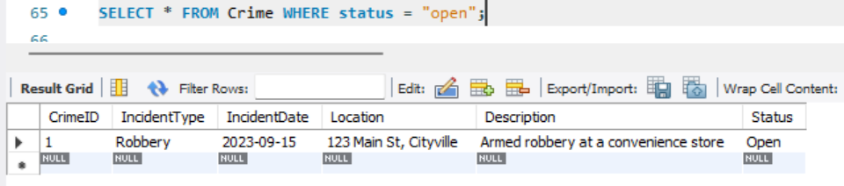

1. ***Find the total number of incidents***

SELECT COUNT(*) AS total_incidents FROM Crime;

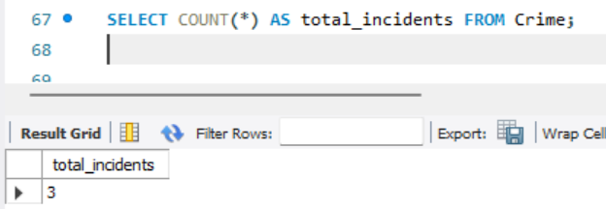

1. ***List all unique incident types***

SELECT DISTINCT IncidentType FROM Crime;

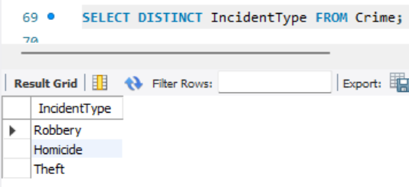

1. ***Retrieve incidents that occurred between '2023-09-01' and '2023-09-10'.***

SELECT * FROM Crime WHERE IncidentDate BETWEEN “2023-09-01” AND “2023-09-10”;

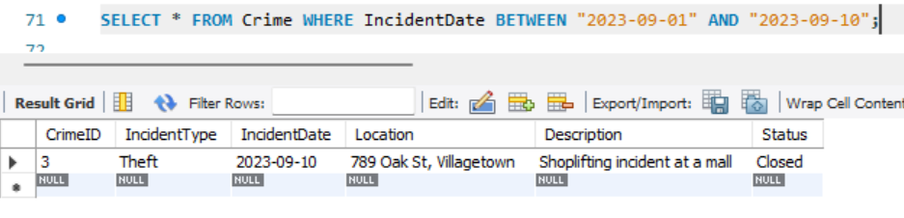

1. ***List persons involved in incidents in descending order of age*.**

SELECT Name, Age, Role FROM Person ORDER BY Age DESC;

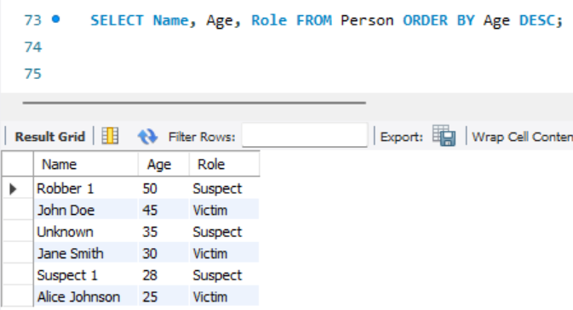

1. ***Find the average age of persons involved in incidents.***

SELECT AVG(Age) AS avg_age FROM Person;

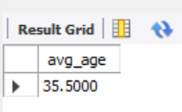

1. ***List incident types and their counts, only for open cases.***

SELECT IncidentType, COUNT(*) AS Count

FROM Crime

WHERE Status = ‘Open’

GROUP BY IncidentType***;***

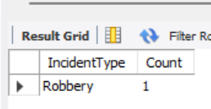

1. ***Find persons with names containing 'Doe'.***

SELECT * FROM Victim WHERE Name LIKE '%Doe%'

UNION

SELECT * FROM Suspect WHERE Name LIKE '%Doe%';

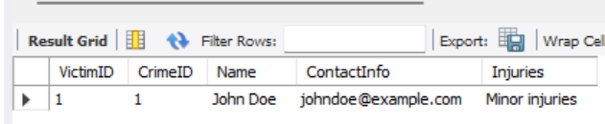

1. ***Retrieve the names of persons involved in open cases and closed cases.***

SELECT V.Name, C.Status

FROM Victim V

JOIN Crime C ON V.CrimeID = C.CrimeID

UNION

SELECT S.Name, C.Status

FROM Suspect S

JOIN Crime C ON S.CrimeID = C.CrimeID;

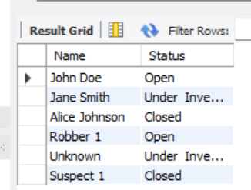

1. ***List incident types where there are persons aged 30 or 35 involved.***

SELECT DISTINCT C.IncidentType

FROM Crime C

JOIN Person P ON C.CrimeID = P.CrimeID

WHERE P.Age IN (30, 35);

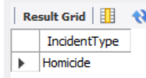

1. ***Find persons involved in incidents of the same type as 'Robbery'.***

SELECT DISTINCT P.Name

FROM Person P

JOIN Crime C ON P.CrimeID = C.CrimeID

WHERE C.IncidentType = 'Robbery';

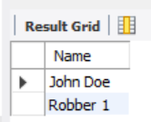

1. ***List incident types with more than one open case.***

SELECT IncidentType

FROM Crime

WHERE Status = 'Open'

GROUP BY IncidentType

HAVING COUNT(*) > 1;

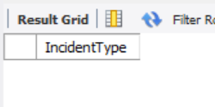

1. ***List all incidents with suspects whose names also appear as victims in other incidents.***

SELECT C.*

FROM Crime C

JOIN Suspect S ON C.CrimeID = S.CrimeID

JOIN Victim V ON S.Name = V.Name;

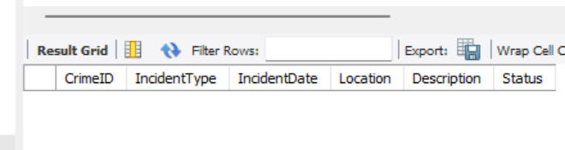

1. ***Retrieve all incidents along with victim and suspect details.***

SELECT C.*, V.Name AS VictimName, S.Name AS SuspectName

FROM Crime C

LEFT JOIN Victim V ON C.CrimeID = V.CrimeID

LEFT JOIN Suspect S ON C.CrimeID = S.CrimeID;

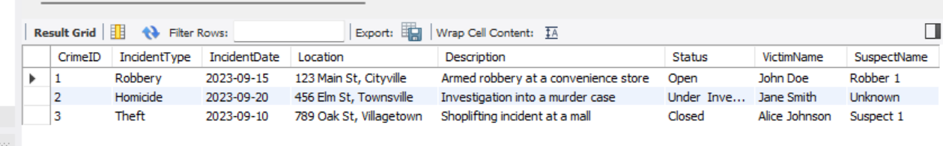

1. ***Find incidents where the suspect is older than any victim.***

SELECT DISTINCT C.*

FROM Crime C

JOIN Person Suspect ON C.CrimeID = Suspect.CrimeID AND Suspect.Role = 'Suspect'

JOIN Person Victim ON C.CrimeID = Victim.CrimeID AND Victim.Role = 'Victim'

WHERE Suspect.Age > Victim.Age;

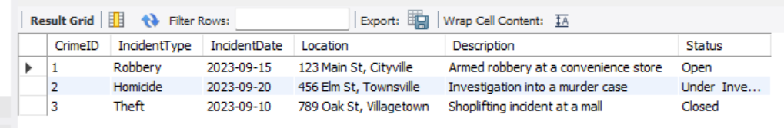

1. ***Find suspects involved in multiple incidents:***

SELECT Name, COUNT(DISTINCT CrimeID) AS CrimeCount

FROM Suspect

GROUP BY Name

HAVING COUNT(DISTINCT CrimeID) > 1;

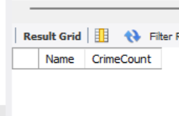

1. ***List incidents with no suspects involved.***

SELECT C.*

FROM Crime C

LEFT JOIN Suspect S ON C.CrimeID = S.CrimeID

WHERE S.CrimeID IS NULL;

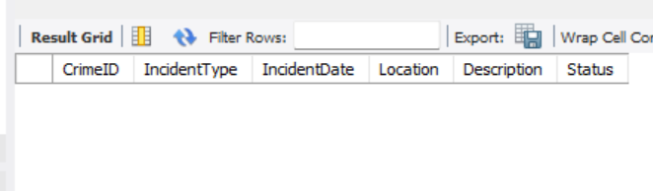

1. ***List all cases where at least one incident is of type 'Homicide' and all other incidents are of type 'Robbery'.***

SELECT * FROM Crime

WHERE IncidentType = 'Homicide'

OR (IncidentType = 'Robbery' AND CrimeID NOT IN (SELECT CrimeID FROM Crime

WHERE IncidentType <> 'Robbery' AND IncidentType <> 'Homicide'));

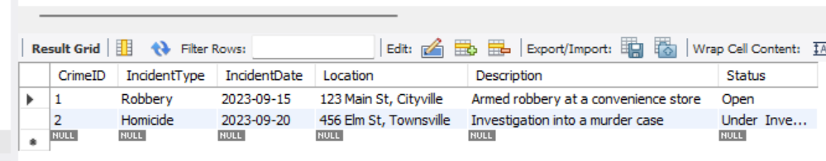

1. ***Retrieve a list of all incidents and the associated suspects, showing suspects for each incident, or 'No Suspect' if there are none.***

SELECT C.CrimeID, C.IncidentType, COALESCE(S.Name, 'No Suspect') AS SuspectName

FROM Crime C

LEFT JOIN Suspect S ON C.CrimeID = S.CrimeID;

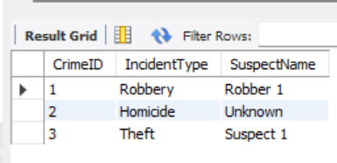

1. ***List all suspects who have been involved in incidents with incident types 'Robbery' or 'Assault'***

SELECT DISTINCT S.Name

FROM Suspect S

JOIN Crime C ON S.CrimeID = C.CrimeID

WHERE C.IncidentType IN ('Robbery', 'Assault');

